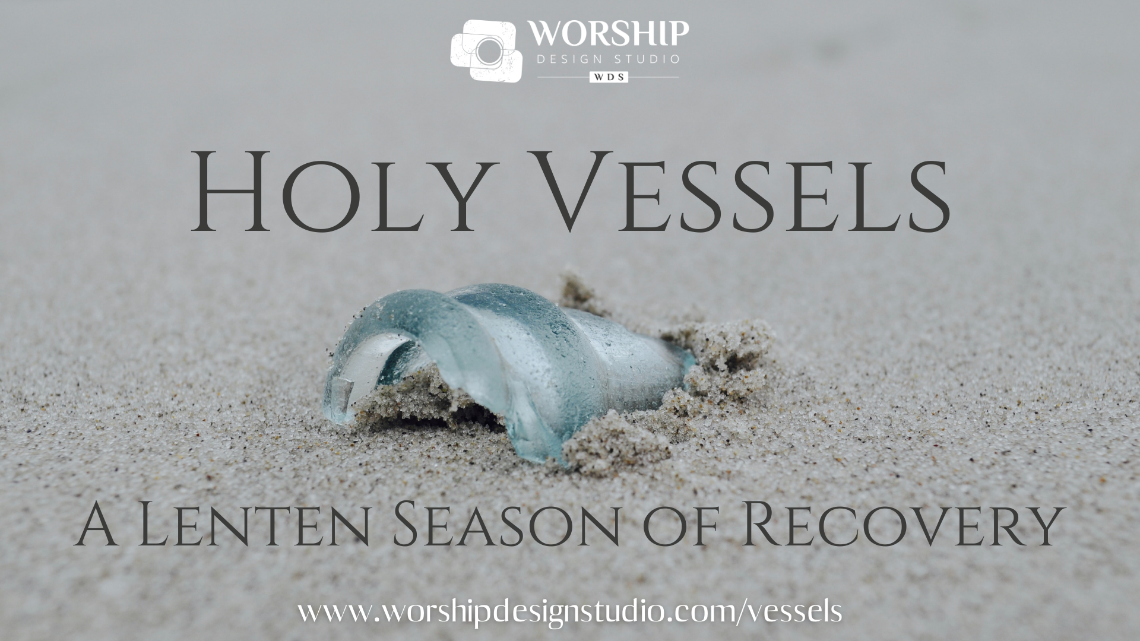
Below is a list of items that will be used during the online worship series for Lent called, Holy Vessels: A Lenten Season of Recovery.

For use during Worship for the Story for all Ages

Ash Wednesday: a pencil (or marker) and a sheet of paper – one for each participant
Lent 1: a pencil (or marker), the sheet of paper from Ash Wednesday (or new one for those who weren’t at Ash Wednesday), clear tape
Lent 2: a blanket
Lent 3: a latex-free adhesive bandage
Lent 4: gather safe, non-breakable items from your home to use as props. (e.g., plastic cups, wooden spoon, strainer, oven mitt, necktie or scarf, comb, cardboard tubes, blocks, box, etc.)
Lent 5: a few objects from nature, such as a houseplant, a few dried leaves, river rocks, etc.
Lent 6: palms to wave
For use during Worship during the Ritual Actions

Ash Wednesday: sand, water, beach/sea glass, candle
Lent 1: beach/sea glass
Lent 2: beach/sea glass, small vessel or bowl,
Lent 3: beach/sea glass, small vessel or bowl, water
Lent 4: beach/sea glass, a flat surface, camera (phone) - optional
Lent 5: beach/sea glass, thin craft wire, camera (phone) – optional
Lent 6: beach/sea glass wrapped in wire

